**EASY ORDER/QUOTE REQUEST FORM**

Please complete the below form, save, and send it back to us. From there we can provide you with an accurate quotation and ensure you receive all the items you require.

|  |  |  |  |  |
| --- | --- | --- | --- | --- |
| **Date** | Click or tap to enter a date. | **Phone Number** | Click or tap here to enter text. | |
| **Name** | Click or tap here to enter text. | **Email Address** | Click or tap here to enter text. | |
| **Company** | Click or tap here to enter text. | **How did you hear about us?** | | Click or tap here to enter text. |
| **Delivery Address** | Click or tap here to enter text. | | | |
| **ETA of your project** | Click or tap here to enter text. | | | |

**Step One – *Choose your Hardware finish***

|  |  |  |
| --- | --- | --- |
|  |  |  |
|  |  |  |
|  |  |  |

**Step Two – *Choose your Ladder Hardware***Note: All of our ladder hardware allows the ladder to store in an upright position when not in use.

***Rolling Ladder Hardware –***

|  |  |  |
| --- | --- | --- |
|  |  |  |
| **Rolling**  The Rolling top roller is designed to fit onto the rail during assembly and is fixed permanently, offering more support and safety. | **Rolling Hook**  The Rolling Hook top roller is designed to allow the ladder to be easily lifted on and off the rail. Ideal if there are multiple rails for the ladder to interchange between. | **Swivel –**  Black Finish Only. To be used in conjunction with curved rails.The Swivel top roller is designed to fit onto the rail during assembly and is fixed permanently.  The swivel on the top rollers enables the ladder to go over our curved rail. |
|  |  |  |

***Non-Rolling Hardware –***

|  |  |  |
| --- | --- | --- |
|  |  |  |
| **Double Hook**  The Double Hook allows your ladder to be hooked at the position required and then simply unhooked to move it about! The two hooks allow you to change between stored position and climbing position. | **Single Hook**  The Single Hook allows your ladder to be hooked at the position required and then simply unhooked to move it about! Unlike the Double Hook, the Single Hook has a sliding mechanism that allows the ladder to interchange between the stored and climbing positions without having to complete lift the ladder of the rail. | **Non-Skid Feet**  Are automatically included in  non-rolling kits, so please skip Step 3 |
|  |  |  |

**Step Three – *Choose your Wheel Style*** (skip this step if you are after a non-rolling ladder)

|  |  |
| --- | --- |
|  |  |
| **Standard Brake Wheel** | **Contemporary Brake Wheel** |
|  |  |

|  |  |
| --- | --- |
| **Straight Rails** | |
| **Rail Lengths** | **Quantity** |
| **4ft (1219mm)** | Click or tap here to enter text. |
| **6ft (1828mm)** | Click or tap here to enter text. |
| **8ft (2438mm)** | Click or tap here to enter text. |

***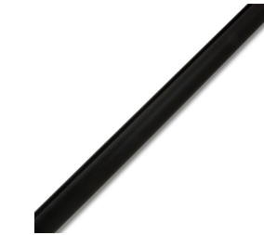*  
Step Four – *Choose your Rail Lengths***Note: Rails can be joined together with splice kits to reach your desired length.

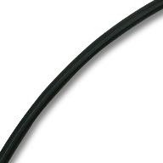

|  |  |
| --- | --- |
| **90* Inside Corner, Curved Rails** | |
| Only Available in Black Finish | |
| **Rail** | **Quantity** |
| **16 Inch Radius** | Click or tap here to enter text. |
| **30 Inch Radius** | Click or tap here to enter text. |

|  |  |
| --- | --- |
| **Splice Kits** | |
| You will need 1 splice kit per join - For example, if you are joining 2 rails together, 1 splice kit is needed. If you are joining 3 rails, 2 splice kits are required. | |
| **How many Splice Kits do you require?** | Click or tap here to enter text. |

**Step Six – *Choose your Brackets and End Caps***Note: We will automatically include Hook brackets for hook hardware and roller brackets for rolling hardware. We will also work out the number of brackets you require based on your rail selection. You will need one pair of end caps per rail section.

|  |  |  |  |  |
| --- | --- | --- | --- | --- |
| **Brackets** | |  | **End Caps (Pairs)** | |
|  |  |  |  |  |
| **Vertical Bracket** | **Horizontal Bracket** | **Ball End Cap** | **Standard End Cap** |
|  |  | Click or tap here to enter text. | Click or tap here to enter text. |

**Step Eight *- Choose your Ladder***Note: We recommend your ladder be 127mm higher than the center of rail. This will allow for the top hardware to operate correctly.

**American Made Stocked Ladders***Please note, all American made* *ladders are supplied flat-packed and come with a decorative top turned rung.*

|  |  |  |  |  |
| --- | --- | --- | --- | --- |
| **Unfinished/Raw Ladders -** *Ready for you to finish with paint or stain!* | |  | **Pre-Finished Ladders -***Coated with a high-quality 30-sheen conversion varnish, so all the hard work is already done!* | |
| **American Oak –** 16” Wide |  | **American Oak –** 16” Wide |  |
| **American Oak –** 20” Wide |  | **Maple –** 16” Wide |  |
| **Maple –** 16” Wide |  |  |  |
| **Maple –** 20” Wide |  |  |  |

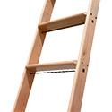

|  |  |  |
| --- | --- | --- |
| **Ladder Height**  *Please note, Pre-Finished Ladders are* ***not*** *available in 10ft (3048mm)* | | |
| **8ft (2438mm)** | **9ft (2743mm)** | **10ft (3048mm)** |
|  |  |  |

**Australian Made Stocked Ladders***Please note, all Australian made ladders are supplied flat-packed and raw.*

|  |  |  |  |  |  |  |
| --- | --- | --- | --- | --- | --- | --- |
| **Wood Species** *Ready for you to finish with paint or stain!* | |  | **Ladder Height** |  |  | **Ladder Width** |
| **Australian Chestnut –**  *(no decorative top rung)* |  | **8ft (2438mm)** |  |  | **16” Wide** |  |
| **Radiata Pine –**  *(no decorative top rung)* |  | **9ft (2743mm)** |  |  | **20” wide** |  |
| **American Oak –**  *(Includes decorative top rung)* |  | **10ft (3048mm)** |  |  |  |  |

***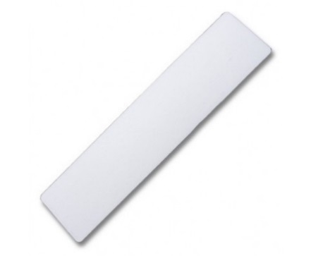*Step Nine– *Extras***

**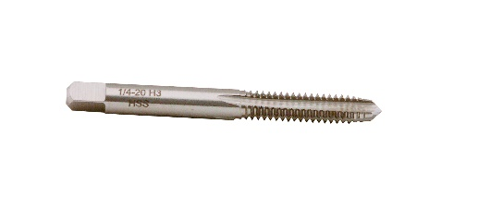*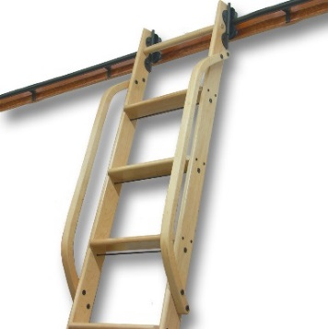***

|  |  |  |  |  |  |
| --- | --- | --- | --- | --- | --- |
| **Handrail** | | **Non-Skid Step Tread Stickers** | | | **Thread Tap** |
| Handrails give extra support when climbing up the ladder. We recommend these on ladders 9ft or higher. | | We recommend these on all ladders. They help stop slipping and wear on the ladder rungs.  Only available on 16” wide | | | Needed to make threads at the end of Round Rails for End Caps. Can be used multiple times. |
| **American Oak** | **Maple** | **x7** for a 8ft Ladder | **X8** for a 9ft Ladder | **X9** for a  10ft Ladder | **Quantity** |
|  |  |  |  |  | Click or tap here to enter text. |

|  |
| --- |
| **Have a question or request for the RHP Team? Let us know here…** |
| Click or tap here to enter text. |

**Once we receive this via email, we will get your quotation under way.**

In the meantime, feel free to contact us on –  
07 3084 3554- [info@ramhardware.com.au](mailto:info@ramhardware.com.au) - [www.ramhardware.com.au](http://www.ramhardware.com.au)